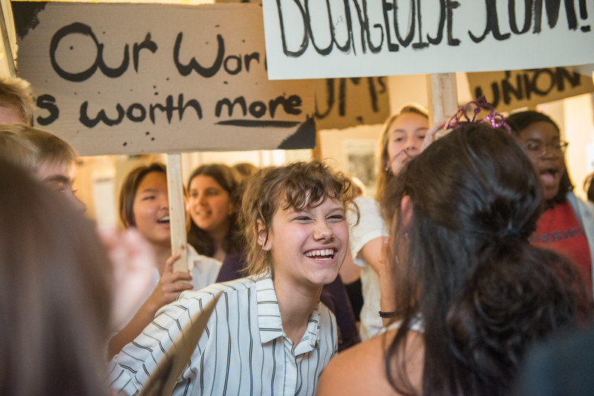 | CAP 9  English Syllabus  DANA SIMEL, 2020-2021
CAP 9 STUDENTS, 2019-2020
Course Description |  | Courtesy of S. Fillman  Texts may include, but are not limited to, the following:  Walden and Civil Disobedience  Maggie: A Girl of the Streets  Romeo and Juliet  Various Works of Poetry  Unbroken  The Joy Luck Club  Modern Short Stories  Coming of Age in Mississippi  To Kill a Mockingbird  The Joy Luck Club  The Chosen  The Autobiography of Miss Jane Pittman
This course is designed to integrate American literature with American history from Reconstruction through the 20th Century. Students will write compositions and will use prescribed writing workshop procedures, which include prewriting activities, initial drafts, edits, revisions, and final drafts.  Objectives  In line with the MCPS English Language Arts Curriculum, this C.A.P. course is designed to encourage “literate, thoughtful, communicators, capable of controlling language effectively...” Students will refine specific skills in reading, writing, speaking, listening, and will use these skills and strategies as tools for learning and reflection.  Assignment Policies  Refer to the CAP 9 Expectations given to all students and posted online.  Grading Breakdown  Assessments – 90%  Practice/Completion – 10%  2nd Qtr. – Assessments 80%, Practice 10%, Progress Check 10% | I will use Canvas to post class assignments. Every class assignment will be posted.  Contact Information  The best way to get in contact with me is through email at dana_simel@mcpsmd.org. I will be teaching during the day, but will check my email in the morning, midday, and late afternoon. Thank you.  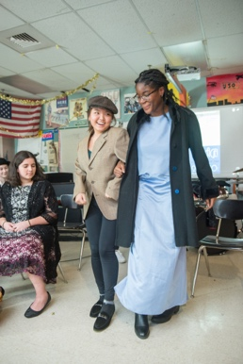  Courtesy of S. Fillman  NOTE: I am more than willing to have individual zoom sessions with students. Parents must be informed of these private sessions, so if you want to zoom with me, please cc your parent when you request a meeting. Thank you.

